# cid:image001.jpg@01D1F959.C0CD4A60

# Traditional Ecological Knowledge (TEK) Review

# COMMUNITY SUMMARY

## August 2016

This Traditional Ecological Knowledge (TEK) Project is a database system managed by the Torres Strait Regional Authority (TSRA) Land and Sea Management Unit (LSMU). The TEK project was initiated by TSRA in 2011 and is now established in nine Torres Strait Island communities through funding from the *National Landcare Program* (NLP) program. The TEK database allows communities to record protect and share traditional knowledge in a culturally appropriate way.

In June 2016, the TSRA Land and Sea Management Unit completed a review of the TEK project to determine what communities thought of the system, how system use can be improved, what traditional knowledge communities would like protected and how the TSRA can work with communities to increase profile of TEK in communities.

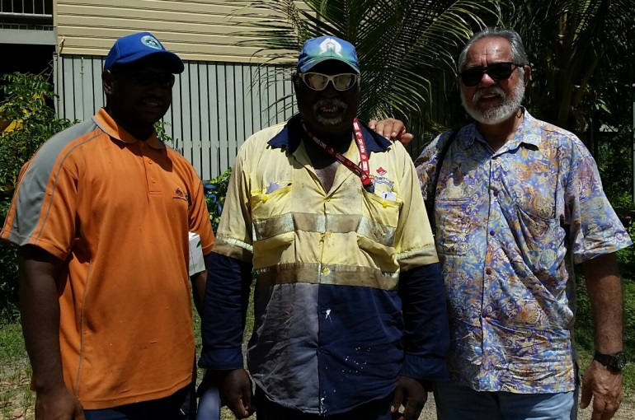

As a part of this review process, TSRA staff spoke to stakeholders from five of the established TEK communities including Boigu, Badu, Mabuiag, Mua and Warraber. A total of 53 stakeholders were interviewed including RNTBC Chairs, interested community members, Councillors, Elders, LSMU Rangers, My Pathway coordinators, project consultants and TSRA staff.

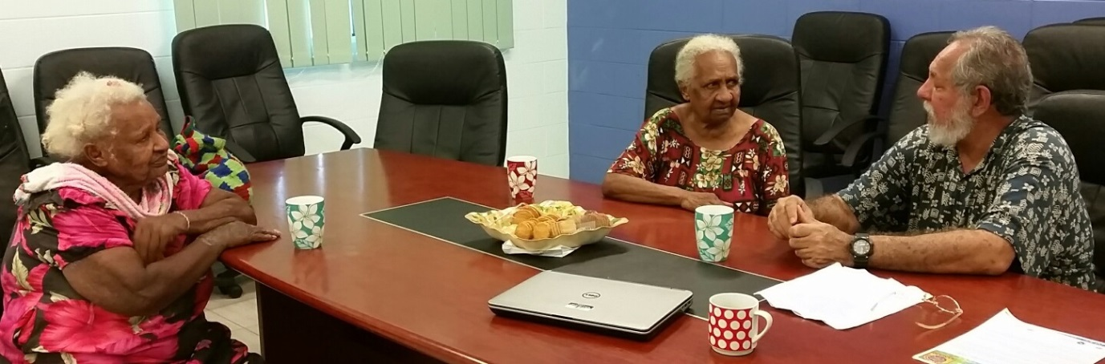

Community consultations with Traditional Owners were framed to determine community opinions of the TEK project, community perceptions on the level of success of the project and suggestions for improving the project into the future. Consultation with the TSRA staff and consultants was framed to determine how TSRA can better incorporate Traditional Knowledge into Land and Sea work, how the usage of TEK Systems can be improved and how TSRA can best staff and resource the TEK Project.

A series of recommendations have come out of the review that outline: how to increase the use of the TEK System in communities, how to better incorporate TEK into TSRA land and sea management planning, and how to best utilise project resources (staff and funding) for the remaining two years of National Landcare Project funding (until June 2018)

The key recommendations arising from the TEK Project Review include:

* Establish a TEK Working Group to prioritise recommendations arising from TEK Review
* Improve community access to TEK systems through investigation of offline data upload
* Further promotion of TEK Systems
* Focus on key TEK communities in order to acquire a baseline level of ecological data in these
* Increase staffing levels for TEK Project to adequately support TEK Systems
* Work with communities to develop discrete TEK projects
* Continue to train rangers and LSMU staff on the importance of TEK, incorporation of TEK into LSMU activities and recording methods for TEK
* Investigate incorporation of TEK data sets into LSMU land and sea management planning
* Review the consultancy arrangement for the TEK Project and redefine deliverables

The following graphs represent how community feel TSRA should promote TEK within Communities to increase system use, what type of TEK communities would like preserved and partnerships that communities identified as key for the success of the TEK Project.

The report highlights both the challenges and opportunities for TSRA to progress development and uptake of the TEK System to June 2018. TSRA has commenced implementing these recommendations and aims to have the majority of these completed with the next 12 months.

TSRA will work toward implementing the recommendations from this review in order to meet the TEK Project goals of:

* Protection of TEK for future generations,
* LSMU on-ground and ranger activities being informed by Ailan Kastom,
* TEK communities accessing the TEK System for their own cultural maintenance,
* Support of sustainable community-based environmental management approaches.

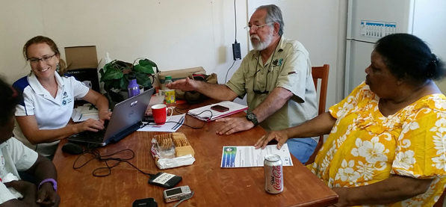

Figure 2 How to promote TEK within communities

Figure 3 **Community priorities for recording and protecting TEK**

Figure 4 Potential partnerships for TEK