Torres Strait Indigenous Protected Areas (IPA’s)
An Indigenous Protected Area is an area of Indigenous-owned land or sea where traditional owners have entered into an agreement with the Australian Government to promote biodiversity and cultural resource conservation.
Indigenous Protected Areas make up part of Australia’s National Reserve System, a nation-wide network of reserves especially set up to protect examples of Australia’s unique landscapes, ﬂora and fauna for current and future generations.
There are three Indigenous Protected Areas in the Torres Strait that are managed by Traditional Owners with support by the Indigenous Land and Sea Rangers employed by the Torres Strait Regional Authority. These are;
- Pulu Islet (on the western side of Mabuiag)
- Warul Kawa
- Warraberalgal/ Porumalgal IPA
The TSRA Land and Sea Rangers visit their respective IPA’s on regular ranger boat patrols and during bi-annual Survey trips. In addition, Land and Sea Rangers raise awareness of the IPA, its management successes and challenges via regular reports and presentations to local communities, Regional Native Title Body Corporate’s (RNTBC’s), stakeholders and local schools.
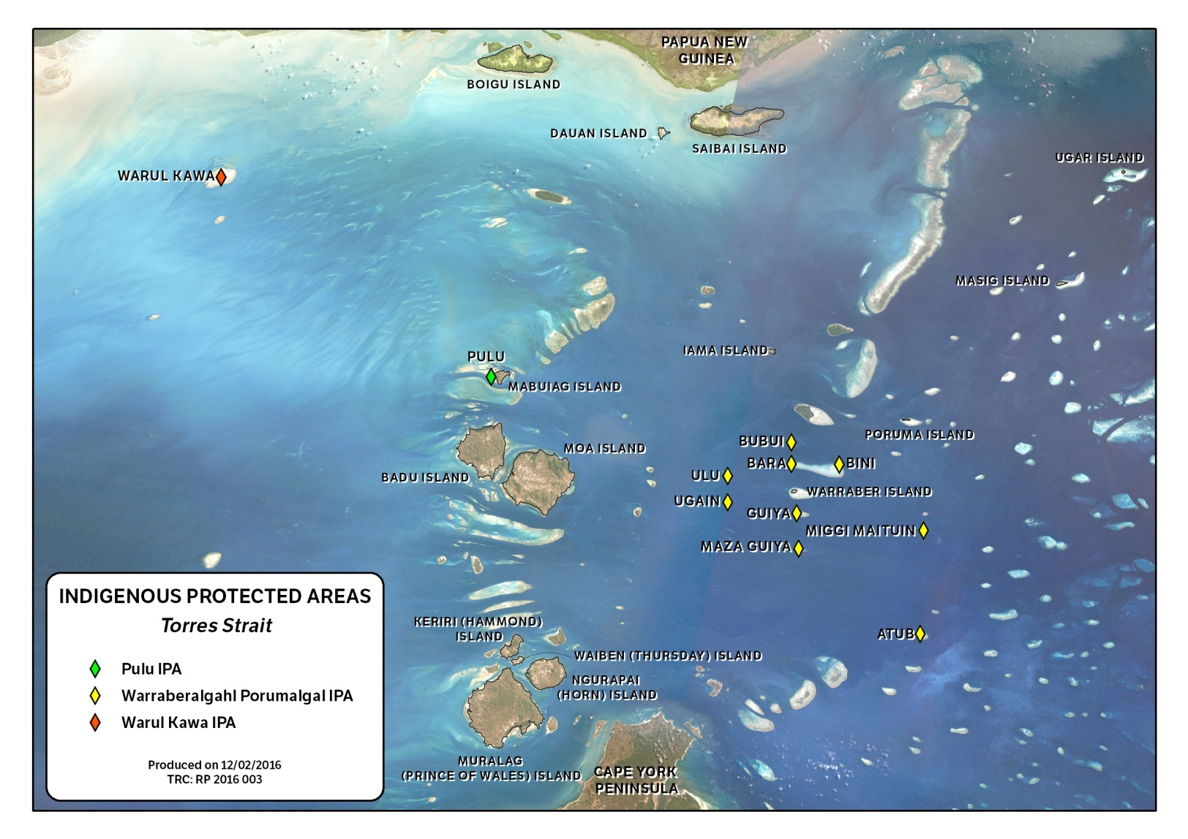

Warul Kawa
Warul Kawa is an islet of great cultural significance to five Torres Strait Islander communities: the people of Boigu, Dauan, Saibai, Mabuiag and Badu. This IPA was declared in 2001 and the native title is held by Maluligal (TSI) Corporation on behalf of the five traditional owner communities. Warul Kawa is an internationally significant turtle nesting site for Flatback, Green and Hawksbill turtles. Warul Kawa means ‘Island of the Turtles’ in Kalaw Kawaw Ya, the language of the northern Torres Strait islands of Boigu, Saibai and Dauan.
Due to its distance from Boigu and other Torres Strait islands, Warul Kawa IPA management activities are undertaken by Land and Sea Rangers during twice-yearly vessel surveys. These surveys incorporate turtle nesting and hatchling counts, pest and weed management activities, visitation management tasks and land and sea management activities.

Pulu Islet
Pulu islet is a small islet on the western side of Mabuiag Island. Pulu is the most important cultural place of the Goemulgaw (people from Mabuiag). The cultural significance centres around two key sites – the ceremonial complex or Kod and the totemic skull cave (Awgadhalkula). Both sites are central to Goemulgaw clan identity and revered across the western Torres Strait. Pulu is the site of Indigenous Australia’s first-known pottery tradition, with red-slipped pottery made from Torres Strait clays dating back between 1500 & 2500 years.
Pulu IPA is managed by Mabuiag rangers who make regular sea patrols to the site, undertaking activities to manage visitors to the island, reduce weeds, pests and marine debris and undertake cultural site preservation.

Warraberalgal/ Porumalgal IPA
The Warraberalgal/ Porumalgal IPA is a series of nine islands around Warraber and Poruma in the Central Islands group. These islands are Bara, Bini, Bubui, Ulu, Ugain, Guiya, Maza Guiya, Miggi Maituin and Atub. These islands were established as an IPA in 2014 by the Kulkalgal (people of Poruma and Warraber) in order to look after ancestral lands and sea country in accordance with Kulkalgal traditions and customs. Native title to the Islands of the IPA is held by both Gau Land Trust and Warraberalgal RNTBC on behalf of the people of Warraber and Poruma.
This IPA is managed by the Warraber and Poruma rangers who undertake regular sea patrols to these islands. In addition, the TSRA LSMU coordinates bi-annual Vessel surveys to visit all islands and undertake visitation management, cultural preservation and land and sea management activities.

For more information on the IPA project, contact the IPA/ TEK Project Officer or Project Manager, Ranger Policy and Planning in Land and Sea Management Unit.

