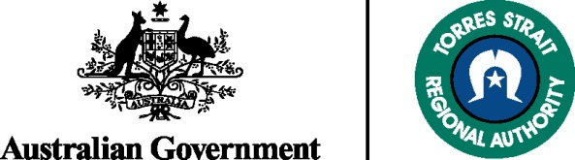

Planning University Study in 2016?

Read this...

Assistance with Tertiary Education Scheme (ATES) Scholarship 2016

The Torres Strait Regional Authority is offering one-year scholarships to assist Torres Strait and Aboriginal people in the Torres Strait region to commence, continue or complete university study. Each scholarship is valued at $6,000.

To be eligible to apply for a scholarship you must be:

- Torres Strait and or Aboriginal living in the Torres Strait region
- Determined to succeed and committed to learning
- Committed to undertaking full time undergraduate or postgraduate on-campus study
- Have lodged your university choices with QTAC
- For continuing students - have attained minimum ‘Pass’ level for all subjects in the past semester
- For post-graduate students – not already hold a post-graduate qualification

Mature-aged students are welcome to apply.

Application kits and further information can be found on our website www.tsra.gov.au or contact Ms Shakira Whap at:

Telephone: (07) 4069 0700

Or e-mail: info@tsra.gov.au

Applications close:

Close of Business
Friday 5 February 2016

